**The Eye Transposed**

**An Exhibit in 5 Parts**

The Eye Transposed is an experimental online photography project, bringing the creativity of photo artists into the high bandwidth network space, a new space for promoting, distributing and collaborating in image creation.

Photographers from around the world have been invited to upload their work to a server providing a base of imagery and art and cultural space and museums have been invited to form work from that base. Tis aspect of the project has already begun and an artists’ network is being established.

The second part is a parallel network of institutions responsible for bringing that work to the public in a program working in collaboration with the artists as well as other similar institutions and centers.

An important feature of this exhibit is that it could be happening in several sites at the same time with each site having its own version, a variation of the available artistic material.

This is an outline of a potential exhibit of that work in five parts.

**Real-Time display from the network**

A wall of screens connected to the network allowing artists to send work in real-time continuously, creating an ever-changing display for the public.

Artists/photographers making up the network of contributors plus others identified by the network of participating centers would be invited to send images live according to a schedule to be determined, filling a wall of several screens with images changing every few minutes. Each screen would represent a site linked over a multicasting platform. MARCEL uses a platform called Access Grid which allows connections between dozens of sites simultaneously and is currently working with an international consortium to build-in artists tools to improve the performance of the platform.

Using the same, it would also be possible to develop a return from the public to the artists through texting.

This aspect of the exhibit would also be used to encourage photographers to collaborate among themselves and present joint productions.

**Navigating Stored Images**

Using an original 3-D display system developed by Jean-Marie Dallet and Frédéric Curien of the [Sliders Lab](http://www.sliderslab.com) at the EESI, Poitiers, the work already uploaded could be seen by a public interacting with 3-D objects made from hundred of photos to select those they wish to see. Imagine a large screen with floating 3-D geometrical object or objects made of images, objects which can be manipulated through a touch screen to pick an individual image and bring it to the fore.



Example of one such object built with Slider. Each element is made up of several images, either a film or a series of individual images. The 3-D figure can contain the entire body of work of a single artist.

Slider Lab has already built an installation for showing the photographic work of Etienne Marey for that museum in Beaune, France.

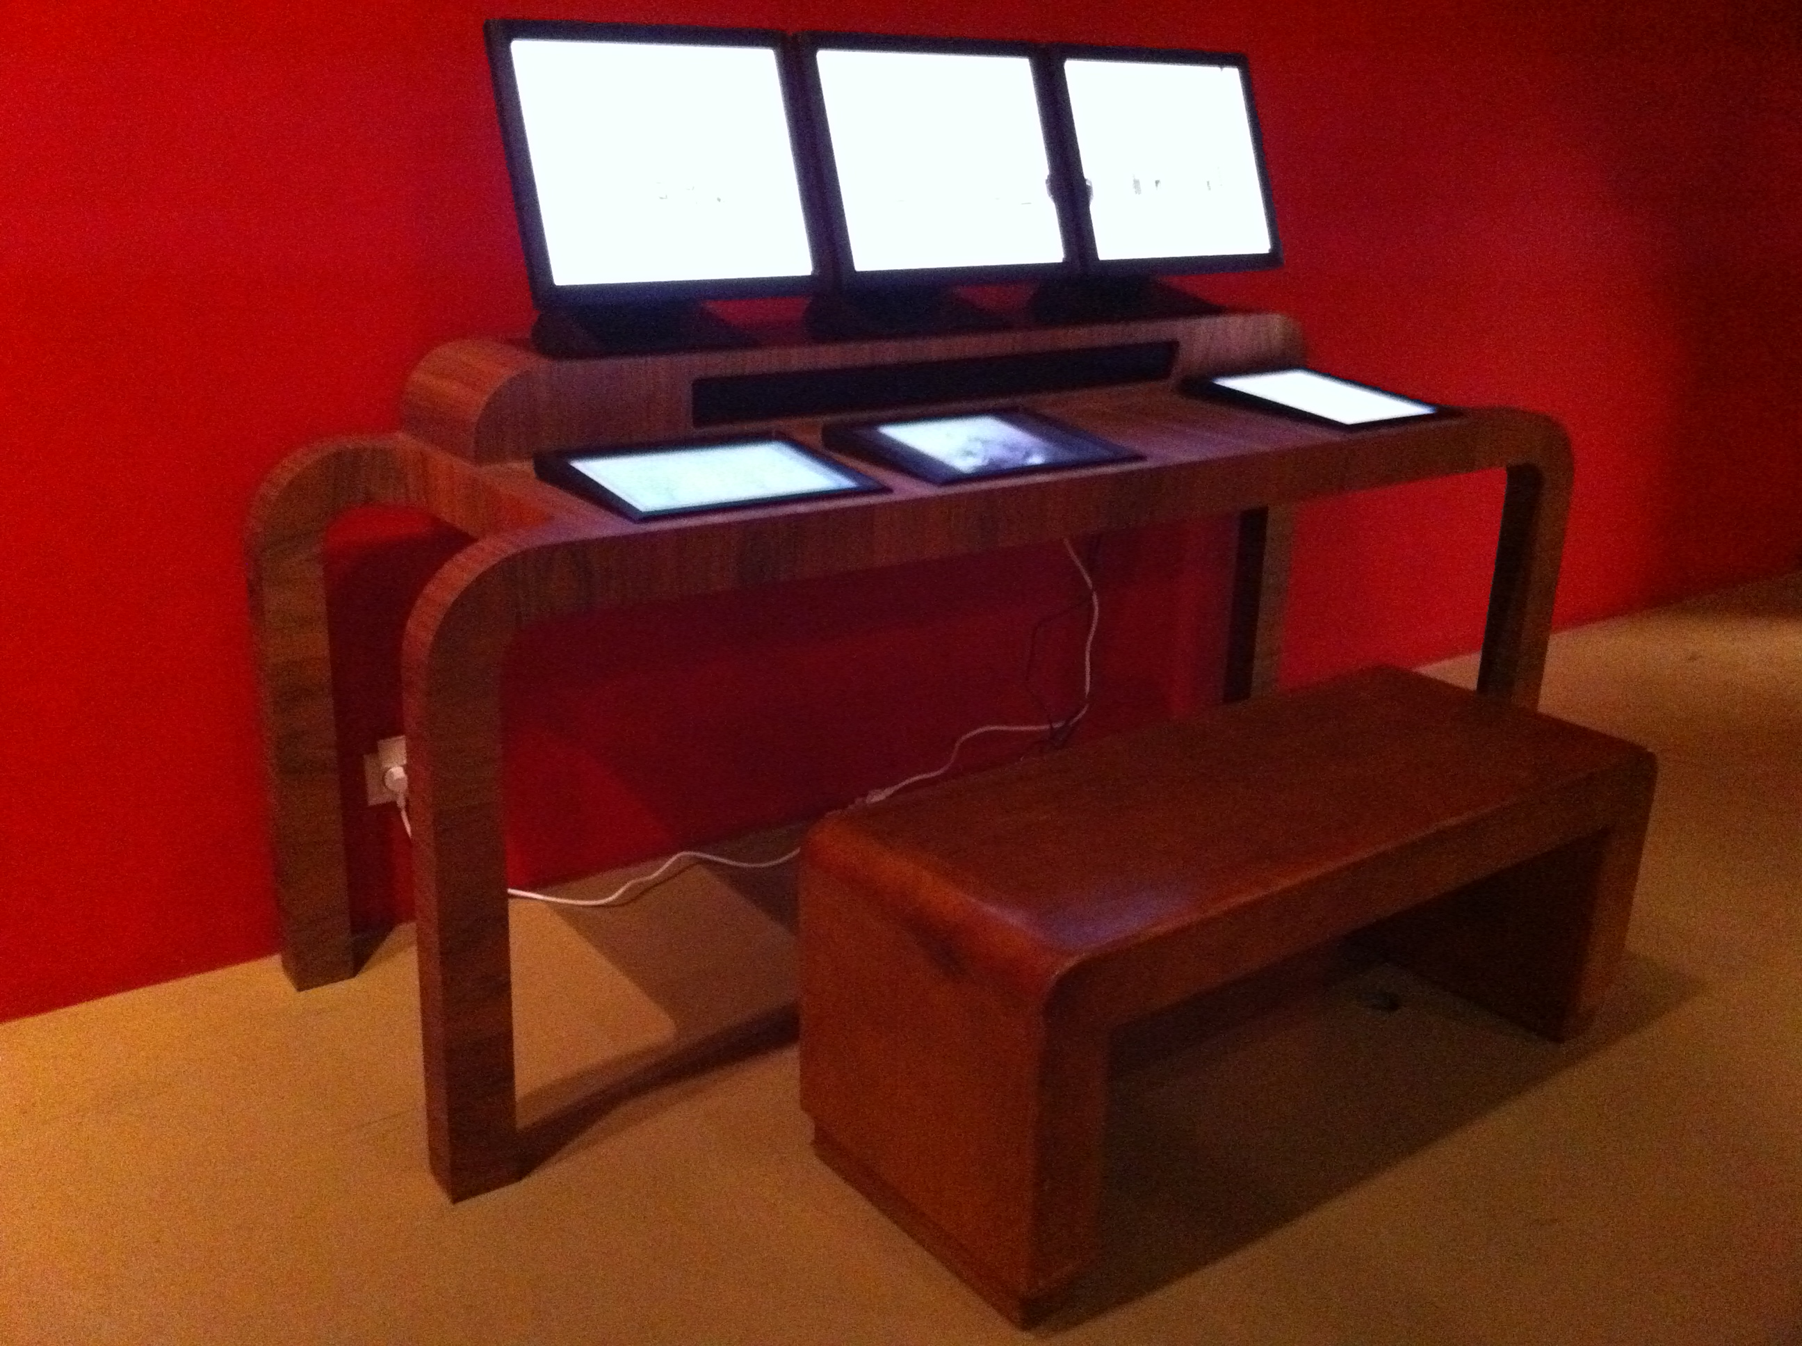

Specially designed furniture for showing Marey’s photos and documentation accompanying it. All operations are touch-screen.

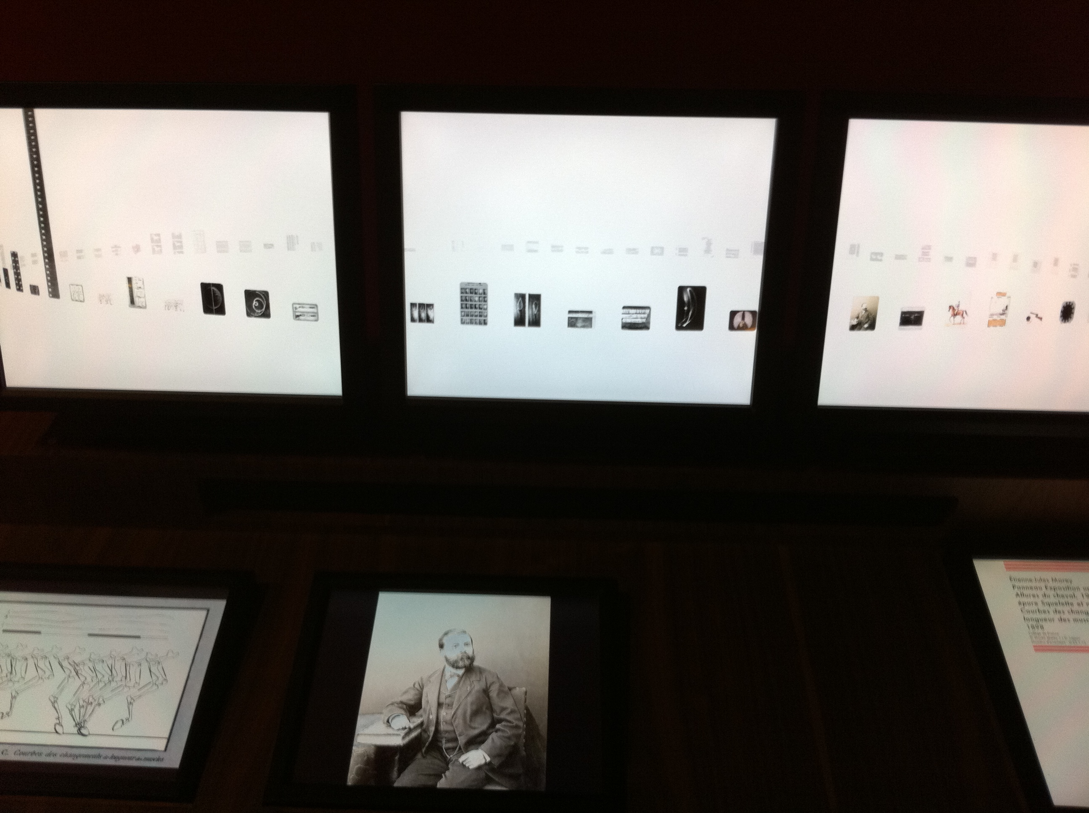

Three screens showing a circle of Marey images. Clicking on any image bring a vertical line of related images.

An installation using Slider could be specially designed for The Eye Transposed. The possible forms are almost unlimited and the user interfaced can be designed for either an intimate, pedagogical experience for individual spectators or a scaled-up more public and playful interface with a larger public.

**Curatorial Pathways**

Another dimension would be setting up curatorial paths through the collected material selected by invited curators according to their own pedagogical or cultural interests. This aspect could be shown on line or using a Slider installation for each curator’s selection, or both.

Such curatorial presentations could be shown throughout the exhibit on smaller screens dedicated to the curator or could be made available to a larger public over the web.

A project for putting Slider on line is being developed by Slider, the Institut de recherché et innovation at the Centre Pompidou with other partners of MARCEL.

**Prints on Walls**

In a bow to past practice, selected work could be printed out and hung for photographers who would prefer that form of presentation. It would also give the public the option of viewing the work in different formats allowing the spectators to judge which they like best or to appreciate the benefits of both.

**Historical**

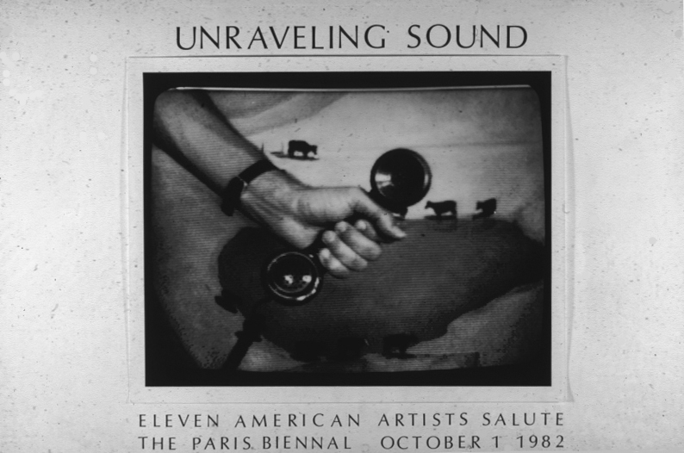In 1982 Meridel Rubenstein and Don Foresta organized an exhibit of French-American photography transmitted by telephone. US funding for international cultural exhibitions had been recently cut and the Director of the Paris Biennale, Georges Boudaille, contacted Foresta saying he no longer had American participation and could he come up with a solution. Foresta had already started his long-term activity with the network in 1981 with an image exchange between the American Center in Paris and the Center for Advanced Visual Studies at MIT. Rubenstein and Foresta had experimented with the technology, Slowscan, for sending images over phone lines and proposed a transatlantic exchange of photos with 11 American and 12 French photographers sending each other images, the first photo exchange by telephone. In Paris the images were photographed again off the receiving screen and hung in the Salle de la Fée de l’Electricité in the Musée de l’Art Moderne de la Ville de Paris. “[Unraveling Sound](http://195.194.24.18/~donforesta/mambo/index.php?option=com_content&task=view&id=28&Itemid=71)”

A celebration of that anniversary would include three sections:

1. a reproduction of a selection of that work shown as it was seen in 1982
2. a presentation of the video tapes of the actual transmission to and from the Paris Biennale, tapes which are now being digitized by the Institut national de l’audiovisuel
3. A reconstitution of the Slowscan process using machines still in Foresta’s procession, refurbished as a form of technical archeology with the Musée des Arts et Metiers, Paris.